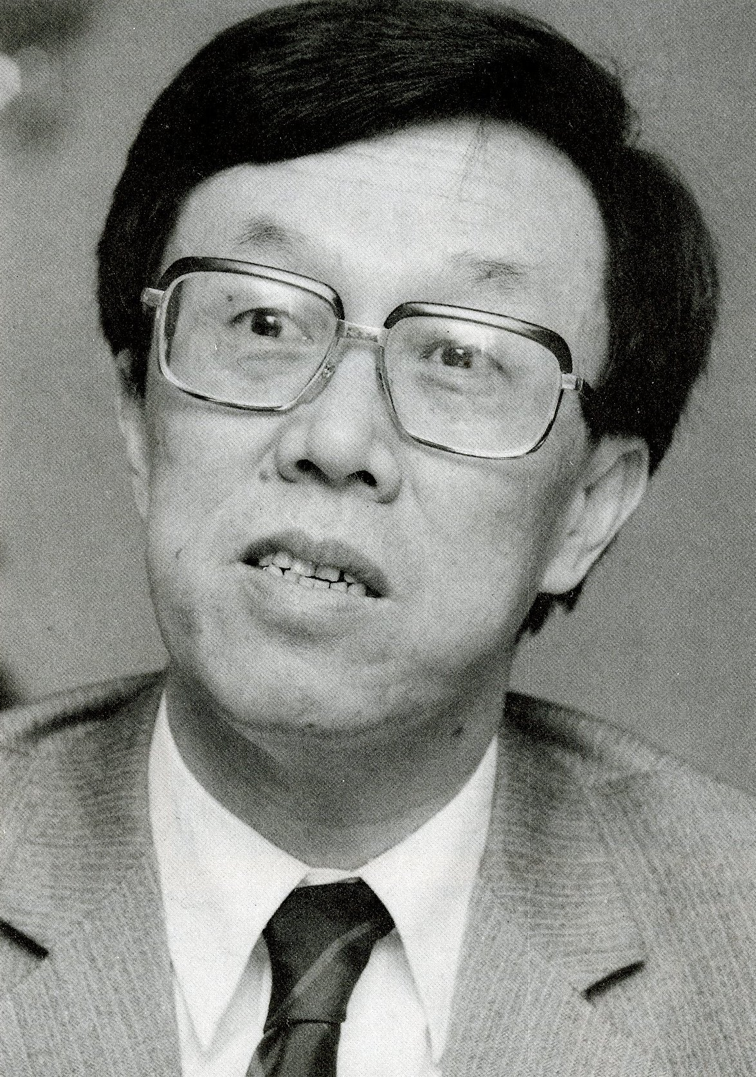
Wang Meng (b. 1934)

Wang Meng is a Chinese author of fiction who is credited with pioneering the introduction of a range of modernist techniques to mainland China in the late 1970s and early 1980s. Wang was born in Beijing on 15 Oct. 1934 and joined the Chinese Communist Party in 1948. He began writing in 1953, although his first novel Long Live the Youth (Qingchun wan sui), strongly influenced by Soviet literary models, was not published until 1979. Wang gained prominence with “The Newcomer” (“Zuzhibu lai le ge nianqing ren,” 1956), a critical reportage published at the height of the liberal “Hundred Flowers” period. Wang was criticized for his outspokenness in 1957 and named a Rightist; he spent much of the next twenty years in banishment in the far Western desert region of Xinjiang, an experience that informed some of his later works.
Wang returned to Beijing in 1978 and began to publish a series of short stories and novels that marked a decisive break with the hitherto dominant style of socialist realism. In short stories such as “Voices of Spring” (“Chun zhi sheng,” 1980) and “The Butterfly” (“Hudie,” 1979), Wang experimented with allusive language, stream of consciousness, and black humor. Wang’s fiction earned both critical acclaim and popular attention in the early 1980s. His best known works include the novels A Bolshevik Salute (Bu li, 1979) and De/Formation (Huodong bian renxing, 1987). Wang’s reputation peaked in the mid 1980s and he became one of the best known Chinese writers at home and abroad. His works from this period have been translated into multiple languages.
Wang became Minister of Culture in 1986, a position in which oversaw a particularly liberal period that witnessed the flourishing of wide range of avant-garde and experimental styles in Chinese literature and arts. He stepped down after the 1989 Tiananmen massacre but remained a moderating voice in the 1990s, speaking out for cultural diversity and tolerance; in 1994, for instance, he intervened on behalf of the writer Wang Shuo, whose “hooligan fiction” had come under attack from conservative bureaucrats. Wang Meng’s later work is voluminous, culminating in the “Seasons” tetralogy (“Jijie sibuqu,” 1993-2000), but never reached the popularity and influence of his 1980s fiction. He continues to publish fiction and non-fiction, including a massive, three-volume autobiographical project.
The novel A Bolshevik Salute carries autobiographical traces, following the ups and downs in the career of a young Communist. Like Wang himself, the protagonist Zhong Yicheng joins the Party as an teenager, yet his youthful idealism is put to a test when political events turn against him; Zhong is denounced and suffers in round after round of political mass campaigns over the next twenty years, until his rehabilitation in the late 1970s. Wang Meng’s decision to discard a chronological narrative in favor of flashbacks, compression, and ellipsis marked a sharp (and sharply felt) departure the dominant narrative paradigms of socialism realism.
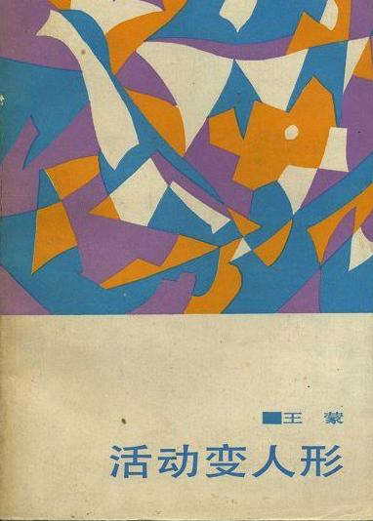
In “Voices of Spring,” Wang Meng experiments extensively with interior monologue and the dissolving of narrative chronology. The protagonist, again a Party cadre rehabilitated after twenty years of suffering, travels home on the eve of the lunar New Year holiday—the first visit to his family in two decades—in a dilapidated and overcrowded railway car. The narrative blends memories of his traumatic experiences with recollections from a recent visit to Western Europe, creating an intimate portrait of the protagonist’s psychological landscape through an extended monologue.
De/Formation is an epic account of family life in twentieth-century China, portraying the conflicts between the protagonist, Ni Wucheng, an unsuccessful intellectual with a thin veneer of Western education, and his wife and in-laws. Taking clues from the writings Eileen Chang, the novel highlights the struggle between traditional and modern values, rendered through changing narrative registers, including irony, extended interior monologues, and shifts in narrative focus to Ni’s young children. The narrative, which is set primarily in the 1940s, is framed by the voice of Ni’s son, traveling in Europe in the early 1980s and seeking to understand the complexities of the intellectual experience of his father’s generation.
Wang’s 1980s novels and short stories attracted considerable debate upon their publication, both in China and abroad. In particular, critics questioned his use of modernist techniques, holding his works against those of James Joyce and Jorge Luis Borges. Wang himself later modified his initial characterization of his style as “stream of consciousness” and admitted that he had but a superficial understanding of Western modernism. Yet in the late 1970s and early 1980s, Wang’s modernist experiments (which coincided with other experimental literary movements, such as the “Misty Poetry” school) helped to popularize new literary techniques that inspired later avant-gardist movements in China.

Main Works:
* “The Newcomer” (1956), trsl. G. Barme. In W.J.F. Jenner (ed.). Fragrant Weeds: Chinese Short Stories Once Labelled as “Poisonous Weeds,” Hong Kong: Joint Publishing, 1983: 71-116.
* A Bolshevik Salute: A Modernist Chinese Novel (1979), trsl. W. Larson, Seattle, University of Washington Press, 1989.
* “The Butterfly” (1979), trsl. G. Yang. In The Butterfly and Other Stories, Beijing, Chinese Literature, 1983: 35-101.
* “Voices of Spring” (1980), trsl. B. S. McDougall. In Chinese Literature 1 (1982): 23-36.
* De/Formation (1987), Beijing: Renmin wenxue chubanshe.

